Tatton Wildlife Newsletter – Winter
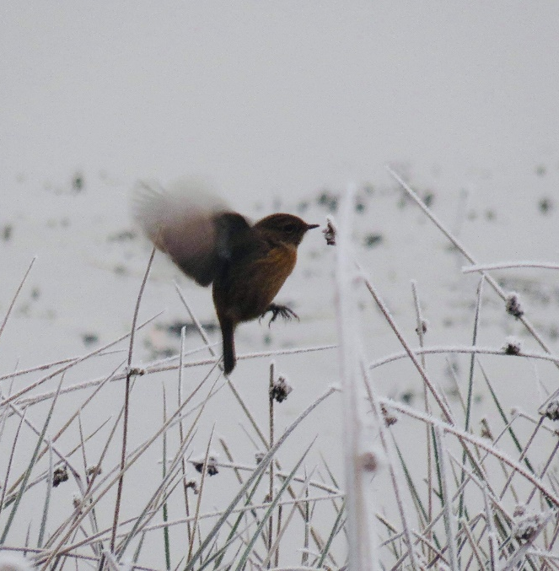
Winter is a wonderful time to get out and enjoy the beautiful parkland scenery and discover the wealth of wildlife that can be found at Tatton. There are health benefits too, not only from the exercise but from connecting with nature which has been proven to help our mental health.
Deer
The rut has now finished, and the deer will begin to herd together again. There have only been some minor injuries during the rut, and this is expected. Given time, deer are known to be able to recover from some quite severe injuries. After the rut, the males initially spend their time eating and regaining the condition that they have lost during the rut.
They now have their winter coats which are thicker and have hollow guard hairs. These trap warm air, keeping them warmer in the winter months.
The tenant farmer’s sheep are taken off the parkland in the autumn. The deer then have less competition for food over the winter when the grass ceases to grow. Supplementary feed is still provided over the winter though and the ranger team feed carrots and haylage daily. The amount varies depending on the severity of the weather.
Birds
Winter birds can now be seen in the park. Redwings and fieldfares have arrived. These winter thrushes can be seen in large numbers, very often feeding on the short grass where the RHS is sited. Peregrine falcons can often be seen at this time of year, the first was a female spotted in October. Other interesting winter birds to look for here at Tatton also include stonechats around the mere edges (pictured above) and meadow pipits on the rough grassland. Woodcocks are often seen as they fly up beneath your feet when disturbed from the woodland floor. Pink- footed geese can be seen, and heard, as they pass over the parkland in large skeins at this time of year.
Although spring is the best time to listen to woodland birds, winter is a good time to see them. The lack of leaves makes them easier to spot and they gather in large flocks at this time of year. There is safety in numbers from predators such as a hungry sparrowhawk and they can also search out and exploit food sources with better efficiency.
Bats and Butterflies
Autumn has been a busy time for bats as this is the mating season. The males will protect a territory and sing to attract any females who pass through. The next four weeks is vital for them to put on weight ready for their winter hibernation. Bats can often be seen on the wing on warmer winter nights.
Tatton’s annual butterfly survey finished at the end of October. After a few quiet months in the early part of spring, good numbers of meadow brown, gatekeeper and ringlet were recorded.
Woodland in the Winter
Winter is sometimes called the dead season, but it is just a resting season – life’s chemical processes, although slowed down, still go on. When the leaves fall in autumn, they lie thick on the ground for a few weeks but in the damp early winter they gradually decay as they are attacked by moulds and fungi. This forms the woodland soil, not just from leaves but from fallen branches and trunks along with animal droppings. The soil and its leaf mould cover provide a deep and fertile layer and a habitat for countless forms of life.

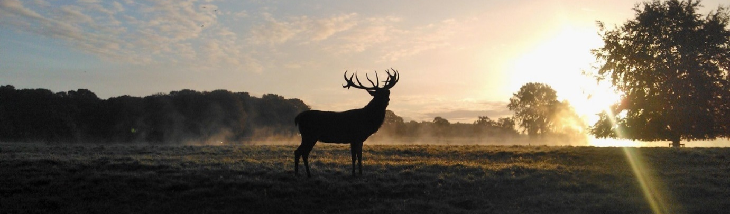

Compiled by Tatton’s Ranger Team

